We need to changed the cluster configuration, Authentication and authorisation permission as showing below image.

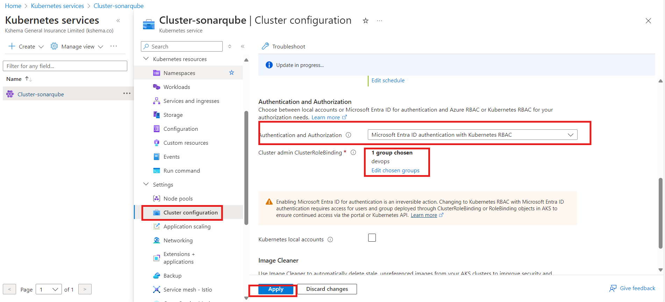

Use below yaml file:-

Cluster role.yaml
---
apiVersion: rbac.authorization.k8s.io/v1
kind: ClusterRole
metadata:
name: readonly-role
rules:
- apiGroups: ["", "extensions", "apps"]
resources: ["pods"] #he can see only pods if put [“*”] all resource
verbs: ["get", "list", "watch"]

Cluster rolebinding.yaml
---
apiVersion: rbac.authorization.k8s.io/v1
kind: ClusterRoleBinding
metadata:
name: read-only-binding
subjects:
- kind: User
name: chaitanya.d@kshema.co
apiGroup: rbac.authorization.k8s.io
roleRef:
kind: ClusterRole
name: readonly-role
apiGroup: rbac.authorization.k8s.io

-----------------------------------------------

